**ASSIGNMENTS ON DIGITAL MARKETING**

**NAME : SABITHA S**

**DEPARTMENT: BE COMPUTER SCIENCE**

**COLLEGE : 8151 DHANALAKSHMI SRINIVASAN INSTITUTE OF TECHNOLOGY**

**NAANMUDHALVAN CURSE : DIGITAL MARKETING**

**NM ID : 6D850C53039AB73AD2544FA5A0A24F04**

**ASSIGNMENT 1**

Create a blog or website using blogspot and word press customize

The theme design and post new article with 500 words.

<https://kingchul.blogspot.com/2023/08/king-event-planner.html>

**ASSIGNMENT 2**

Create a new Facebook business page and post one social media poster for your brand.

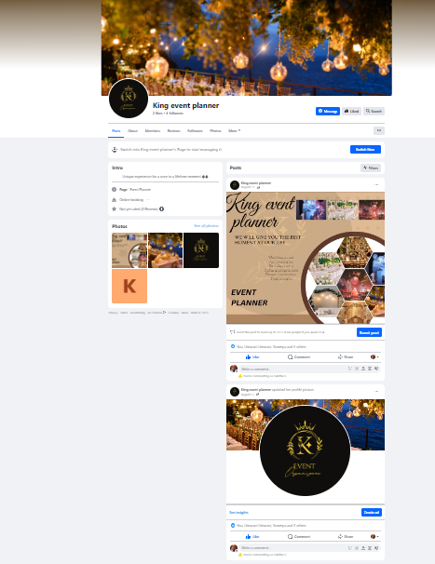

FTH



<https://www.facebook.com/people/King-event-planner/61550543158131/?mibextid=ZbWKwL>

**ASSIGNMENT 3**

Create and design a social media advertisement poster using Canva

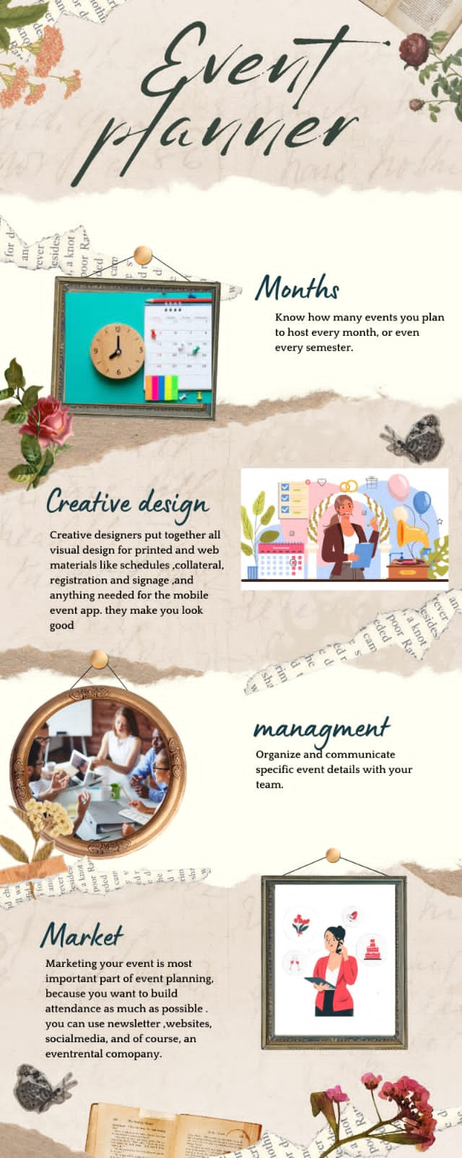

**ASSIGNMENT 4**

Create email newsletter design using mail chimp or Canva tool

